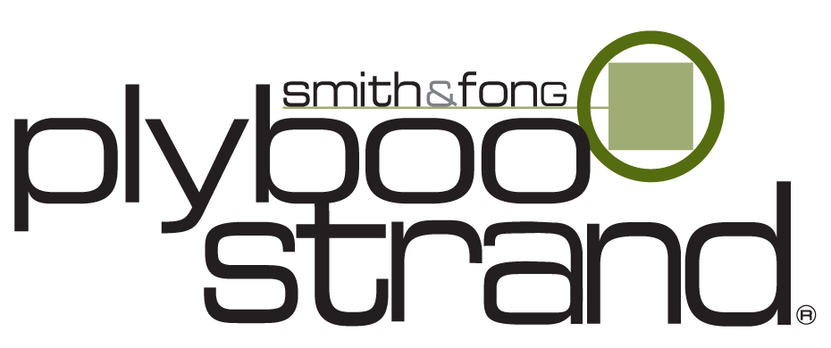  Bamboo plywood  plyboostrand®, Neopolitan®  product specification  in CSi 3-part format | Smith & Fong Company  475 – 6th Street  San Francisco, CA 94103  Phone: (415) 896-0577  Toll Free: (866) 835-9859  Fax: (415) 896-0583  Website: www.plyboo.com  E-mail: sales@plyboo.com

******************************************************************************
GENERAL NOTES TO SPECIFIER:

pLEASE GO TO WWW.PLYBOO.COM AND CHECK IN THE SPECIFICATIONS SECTION TO VERIFY THIS IS THE MOST CURRENT VERSION.

THE FOLLOWING PRODUCT SPECIFICATION LANGUAGE IS INTENDED TO ASSIST DESIGN PROFESSIONALS IN specifying bamboo plywood in EXISTING 3-part specifications for paneling, casework, doors, and similar architectural woodwork.

SAMPLE LANGUAGE IS PROVIDED FOR APPLICABLE ARTICLES IN PART 1–GENERAL AND PART 2–PRODUCTS FOLLOWING THE CONSTRUCTION SPECIFICATION INSTITUTE’S SECTIONFORMAT. BECAUSE OF THE VARIATION IN SPECIFICATION SYSTEMS CURRENTLY IN USE, ARTICLE AND PARAGRAPH numbers and TITLES MAY DIFFER SOMEWHAT THAN PRESENTED HEREIN. THE SAMPLE LANGUAGE SHOULD BE EDITED ACCORDINGLY TO FIT EACH FIRM’S SPECIFICATIONS.

ARTICLES AND PARAGRAPHS OF THIS PRODUCT SPECIFICATION ASSUME THE PROJECT MANUAL WILL CONTAIN COMPLETE DIVISION 1 DOCUMENTS INCLUDING 01 25 13−PRODUCT SUBSTITUTION PROCEDURES, SECTIONS 01 33 00−SUBMITTAL PROCEDURES, 01 62 00−PRODUCT OPTIONS, 01 66 00−PRODUCT STORAGE AND HANDLING REQUIREMENTS, 01 74 00−cLEANING and waste management, 01 77 00−CLOSEOUT PROCEDURES, AND 01 78 00−CLOSEOUT SUBMITTALS. CLOSE COORDINATION WITH DIVISION 1 SECTIONS IS REQUIRED. IF THE PROJECT MANUAL DOES NOT CONTAIN THESE SECTIONS, ADDITIONAL INFORMATION MAY BE INCLUDED UNDER THE APPROPRIATE ARTICLES.

NOTES TO THE SPECIFIER ARE IN ALL UPPER CASE TEXT AND ARE CONTAINED within rows of asterisks.

GREY HIGHLIGHTED GREEN TEXT AND NOTES RELATE TO LEED® PROJECTS AND CAN BE DELETED IF THE PROJECT IS NOT INTENDED TO ATTAIN leed® CERTIFICATION.

OPTIONAL ITEMS REQUIRING SELECTION BY THE SPECIFIER ARE ENCLOSED WITHIN BRACKETS, E.G. [35] [40] [45]. MAKE APPROPRIATE SELECTIONS AND DELETE OTHERS.

******************************************************************************

SECTION 06 42 00
Wood Paneling

PART 1 – GENERAL

  - SUMMARY

Section Includes:
*************************************************************************************
ADD SUBPARAGRAPH IDENTIFYING THE ITEMS MADE WITH BAMBOO PLYWOOD.
*************************************************************************************

Related Sections:
*************************************************************************************
INCLUDE ALL DIVISION 01 SECTIONS CONTAINING LEED® REQUIREMENTS.
*************************************************************************************

1.02 REFERENCES

*************************************************************************************
IF THE “REFERENCES” ARTICLE IS USED, INCLUDE THE FOLLOWING IN THE REFERENCE LIST:
*************************************************************************************

ASTM – American Society for Testing and Materials:
      - ASTM E84, Standard Test Method for Surface Burning Characteristics of Building Materials.

      - ASTM D1037, Standard Test Methods for Evaluating Properties of Wood-Base Fiber and Particle Panel Materials.

      - ASTM D3043 Standard Test Methods for Flexural Structural Panels in Flexure.

ASTM D3500, Standard Test Method for Structural Panels in Tension.

ASTM D4442, Standard Test Methods for Direct Moisture Content Measurement of Wood and Wood-Base Materials.

ASTM E1333, Standard Test Method for Determining Formaldehyde Concentrations in Air Emission Rates from Wood Using a Large Chamber.

American National Standards Institute/Hardwood Plywood and Veneer Association

US Green Building Council’s Leadership in Energy and Environmental Design Green Building Rating System® (LEED).

1.03 SUBMITTALS

    - Product Data
*************************************************************************************
INCLUDE THE FOLLOWING IN THE “PRODUCT DATA” PARAGRAPH:
*************************************************************************************
1. Bamboo plywood manufacturer’s product data.

B. LEED Submittals:
*************************************************************************************
INCLUDE THE FOLLOWING FOR LEED PROJECTS, AS APPLICABLE.
*************************************************************************************

MRc6, Rapidly Renewable Materials: Bamboo plywood [manufacturer’s product data for each product used, indicating that product(s) are manufactured from a rapidly renewable resource]

1.04 WARRANTY
*************************************************************************************
INCLUDE THE FOLLOWING WARRANTY
*************************************************************************************
- A Warranty for Smith & Fong Plyboo Products referenced at www.plyboo.com

PART 2 – PRODUCTS

2.01 MATERIALS
*************************************************************************************
INCLUDE THE FOLLOWING PARAGRAPHS AND SUBPARAGRAPHS FOR BAMBOO PLYWOOD AS APPROPRIATE.
*************************************************************************************
  - Bamboo Plywood
- Manufacturer: Smith & Fong Company, San Francisco, CA 94103

Tel: (866) 835-9859

E-mail: sales@plyboo.com

Website: www.plyboo.com
- Species: Moso (Phyllostachys Pubescens)
*************************************************************************************
INCLUDE THE FOLLOWING SUBPARAGRAPH IF PRODUCTS ARE USED FOR WALL OR CEILING FINISHES PURSUANT TO IBC SECTION 803.
*************************************************************************************
- Fire Resistance Classification: [Class C].

Test surface burning characteristics in accordance with ASTM E 84.
*************************************************************************************
SELECT APPROPRIATE TYPE(S) BELOW TO SUIT PROJECT REQUIREMENTS. DELETE THOSE NOT USED. FABRICATION ARTICLE OR DRAWINGS MUST CLEARLY IDENTIFY SPECIFIC USES.
PRODUCTS: GO TO http://www.plyboo.com/ FOR AVAILABLE FACE DIMENSIONS.
*************************************************************************************

- Type

a. 3/4 inch thick, 3-ply

[Havana Strand] [Neopolitan Strand] [Sahara Strand]

b. 5/32 inch thick (4 mm), 1-ply

[Havana Strand] [Neopolitan Strand] [Sahara Strand]

5. Physical/Mechanical Properties [3/4” thick, 3-ply, cross core strand]:
- ASTM E84: Surface Burning, Class C
- ASTM D1037:
  - Dimensional Stability
    - Linear Expansion (AR to 20% RH): Par. -0.04%, Per. -0.07%
    - Thickness Swell (AR to 20% RH): -0.13%
  - Screw Hold (face / back / edge): 742 lbs. / 831 lbs. / 860 lbs. (avg.)
- ASTM D3043: Static Bending
  - Density: 50 lbs./ft³
  - MOE / MOR (parallel): 268,000 psi / 14,762 psi
- ASTM D3500: Tensile Strength
  - Load (parallel / perpendicular): 1,730 lbs. (avg.) / 1,600 lbs. (avg)
  - Strength (parallel / perpendicular): 5,970 lbs psi (avg.) / 1,060 psi (avg.)
- ASTM D4442: Moisture Content, 4% - 7% (avg.)
- ASTM E1333: Formaldehyde Emissions, 0.02 ppm

B. Accessories
a. Edge Banding, 3/16 inch (4mm) thick by 30 inches wide by 72 inches in length
i. [Havana Strand] [Neopolitan Strand] [Sahara Strand]

End OF PRODUCT SPECIFICATION

